A Sentiment-Adjusted Black-Scholes Simulation of a Weekly Covered-Call Recovery Strategy
RR, ONDS, POET, and USAR Position-Level Research Report
Prepared by: Harsh Choksi
Date: June 10, 2026
This document is a quantitative strategy model and research memo. It is not financial, legal, tax, or employment compliance advice. Live option chains, employer trading policies, liquidity, taxes, and broker rules should be checked before any trade is placed.

Abstract
This paper formalizes and stress-tests a weekly covered-call strategy for four high-volatility equity positions: RR, ONDS, POET, and USAR. The strategy sells one-week calls on Mondays only when the selected strike is at least the maximum of the modeled current stock price and the investor's average cost. Among eligible strikes, the strategy chooses the highest strike whose modeled bid divided by strike is at least 1.38462%. The stock-price path is modeled as a sentiment-adjusted geometric Brownian motion, where option put/call volume modifies the weekly drift. Call values are estimated with the Black-Scholes model, then haircut to approximate the bid. Weekly assignment probability is calculated from a lognormal finish-above-strike probability. The assignment week reported in the main result is not the first week where cumulative assignment probability crosses a threshold; it is the week with the highest single-week assignment probability under the final strike-selection rule. Under the baseline inputs, POET is projected to have the earliest and cleanest setup, followed by RR, ONDS, and USAR. The result is highly sensitive to implied volatility, future put/call volume, strike availability, liquidity, and the assumed sentiment drift.
Keywords: covered calls; Black-Scholes; assignment probability; put/call ratio; implied volatility; options income; geometric Brownian motion; risk management.

Table of Contents
1. Introduction and Research Objective
2. Position Data and Market Snapshot
3. Strategy Definition
4. Mathematical Methodology
5. Strike-Selection Algorithm
6. Results
7. Ticker-Level Show Work
8. Interpretation and Portfolio Ranking
9. Risk, Limitations, and Practical Controls
10. Conclusion
References
Appendix A. Model Inputs
Appendix B. Weekly Checkpoint Tables
Appendix C. Formula Sheet

1. Introduction and Research Objective
The objective of this report is to convert the covered-call recovery idea discussed in the prior analysis into a formal, repeatable research model. The investor currently holds shares of RR, ONDS, POET, and USAR at average costs above or near current market prices. The strategic goal is to sell weekly covered calls to reduce effective basis and create a disciplined exit point, while maintaining a strict rule that assignment should occur only at a strike above the original average cost.
The core question is: if the strategy is repeated every Monday and the highest qualifying strike is selected each week, which ticker is most likely to be assigned, in which week, at what strike, and with what modeled profit? The analysis is not intended to predict the exact future. Instead, it produces a decision framework that can be refreshed every Monday using live prices, live implied volatility, and live put/call volume.
A covered call, as described by the Options Clearing Corporation, involves owning shares and selling a call option against those shares. The strategy can generate income, define an exit price, and reduce effective cost basis, while also capping upside above the short-call strike [2]. Assignment risk exists because an option buyer has the right to exercise; OCC assignment procedures and broker rules affect the mechanics of whether the short call is assigned [3].

2. Position Data and Market Snapshot
The position inputs below are taken from user-provided brokerage screenshots and the market snapshot used in the previous analysis. Because prices, option chains, and put/call ratios change quickly, this table should be refreshed before executing the strategy each Monday.
Ticker | Shares | Start price S0 | Avg cost A | IV used | PCR used | Intraday high | Intraday low | Volume
RR | 7400 | $2.30 | $3.78 | 134.76% | 0.07 | $2.50 | $2.20 | 8,769,562
ONDS | 1700 | $9.65 | $12.20 | 102.21% | 0.5 | $10.66 | $9.05 | 69,199,663
POET | 2800 | $10.77 | $12.25 | 133.16% | 0.32 | $12.77 | $10.12 | 43,423,499
USAR | 400 | $20.90 | $26.95 | 102.83% | 0.61 | $23.00 | $19.90 | 22,300,109
Table 1. Baseline position and market input table.
USAR note: if the actual USAR share count is 200 rather than 400, divide the USAR total profit values by 2. Per-share calculations do not change.

2.1 Data Reliability and Refresh Rule
The model uses implied volatility and put/call volume as current-market inputs. Barchart defines options put/call ratios and reports current-session put volume, call volume, and put/call volume ratio; it also describes low put/call ratios as generally bullish and high put/call ratios as bearish [4]. Barchart also explains implied volatility and IV rank/percentile as measures of expected movement embedded in options prices [5]. These values are not stable. They must be refreshed on every Monday scan.
The report therefore distinguishes between (a) the strategy logic, which is reusable, and (b) the numerical outputs, which are conditional on the current snapshot. The work below should be interpreted as a baseline simulation, not a permanent forecast.

3. Strategy Definition
The final strategy rule is intentionally strict. It prevents selecting below-cost strikes and avoids choosing the nearest call simply because it has higher assignment risk. Instead, it maximizes the strike while preserving a minimum premium yield.
B_t = max(S_t, A) (1)
where B_t is the weekly strike floor, S_t is the modeled Monday stock price, and A is the original average cost of the position.
K_t >= B_t (2)
This condition ensures that any assignment is at or above both the modeled current price and the original average cost.
Return_t(K) = Bid_t(K) / K (3)
Return_t(K) >= 0.0138462 (4)
The number 0.0138462 equals the required weekly bid/strike return of 1.38462%. The selected strike is the highest strike that satisfies both the strike floor and the return requirement:
K_t = max{K : K >= max(S_t,A), Bid_t(K)/K >= 0.0138462} (5)
If no strike satisfies the rule, no call is sold that week in the baseline model. Premium is recorded as zero and assignment probability is set to zero for that week.

4. Mathematical Methodology

4.1 Stock Price Process
The modeled stock path uses geometric Brownian motion, a standard continuous-time model for equity prices:
dS_t = mu_t S_t dt + sigma S_t dW_t (6)
For weekly simulation, the expected Monday path is simplified to a deterministic sentiment-adjusted drift path:
S_t = S_0 exp(g(t-1)) (7)
This deterministic path is not a claim that the stock will move smoothly. It is the model's base path around which weekly lognormal uncertainty is used for assignment probabilities.

4.2 Weekly Volatility
sigma_w = sigma sqrt(5/252) (8)
Here sigma is annualized implied volatility, and sigma_w is the five-trading-day weekly volatility used in the finish-above-strike probability. A 252-trading-day year is assumed.

4.3 Put/Call Volume Sentiment Drift
The put/call ratio is incorporated as a mild sentiment drift adjustment. Since lower put/call volume ratios often indicate more call demand relative to put demand, the model assigns a positive drift when PCR is below the neutral threshold and a negative drift if PCR is above it. This is not a universal law; it is a modeling assumption used to translate options flow sentiment into a weekly path estimate.
g = clip(0.15 sigma_w ln(0.70/PCR), -0.04, 0.04) (9)
The 0.70 threshold is consistent with options-market convention that lower put/call ratios can be interpreted as bullish, while higher ratios can be bearish [4]. The weekly drift is capped at +/-4% to avoid allowing sentiment alone to dominate the model.

4.4 Black-Scholes Pricing
Weekly call values are estimated using the Black-Scholes formula for a European call. The original Black-Scholes paper introduced the option-pricing framework used here [1].
C = S N(d_1) - K exp(-rT) N(d_2) (10)
d_1 = [ln(S/K) + (r + sigma^2/2)T] / [sigma sqrt(T)] (11)
d_2 = d_1 - sigma sqrt(T) (12)
The model then converts theoretical mid value to a modeled bid using a liquidity haircut:
Bid = floor_to_cent(0.85 C) (13)
The haircut acknowledges that retail orders typically transact closer to bid than mid when selling options, and that thin chains may have poor liquidity. The floor-to-cent operation makes the model more conservative by not rounding up option premium.

4.5 Weekly and Cumulative Assignment Probability
Assignment probability is modeled as the probability that the stock finishes above the selected call strike by Friday. This is a simplification; real American-style equity options may be exercised before expiration, and OCC/broker assignment procedures affect actual assignment [3].
q_t = P(S_Friday >= K_t) (14)
q_t = 1 - Phi([ln(K_t/S_t) - g] / sigma_w) (15)
The cumulative probability that assignment has occurred by week n is:
P_cum,n = 1 - product_{i=1}^{n}(1 - q_i) (16)
The final assignment week reported in this paper is the week where q_t is highest under the final strategy rule. Cumulative probability remains important as a risk metric, but it is no longer used to select the assignment week.

4.6 Profit if Assigned
Profit_n = N [K_n - A + sum_{i=1}^{n} p_i] (17)
N is shares, K_n is the selected strike in the assignment week, A is original average cost, and p_i is the actual modeled premium per share collected in week i. Premiums reduce effective basis linearly:
A_effective,n = A - sum_{i=1}^{n} p_i (18)
However, the strategy rule itself continues to use max(S_t,A), not the reduced effective basis, unless the strategy is explicitly changed later.

5. Strike-Selection Algorithm
The following algorithm is the exact final strategy simulated in this report:
1. Start each Monday with the modeled current price S_t, original average cost A, annualized implied volatility sigma, put/call ratio PCR, and available strike increment.
2. Compute B_t = max(S_t, A).
3. Build the candidate strike grid using listed-style increments. RR, ONDS, and POET use $0.50 increments; USAR uses $1.00 increments.
4. Remove all strikes K < B_t.
5. For each remaining K, compute Black-Scholes call value C.
6. Convert C to modeled bid: Bid = floor_to_cent(0.85 C).
7. Compute Bid/K.
8. Keep only strikes with Bid/K >= 1.38462%.
9. Choose the highest remaining strike. If no strike remains, skip that week.
10. Calculate weekly assignment probability q_t and update cumulative assignment probability.
11. Repeat until the horizon is complete. Select the week with highest q_t as the modeled assignment week.

6. Results
Table 2 summarizes the final modeled output under the strict highest-qualifying-strike rule.
Ticker | Assign week | S_t | B_t | K_t | Bid | Bid/K | q_t | P_cum | Cum prem/share | Profit
RR | 13 | $3.72 | $3.78 | $4.00 | $0.14 | 3.50% | 43.02% | 73.13% | $0.31 | $3,922
ONDS | 26 | $11.57 | $12.20 | $12.50 | $0.27 | 2.16% | 31.38% | 80.63% | $1.15 | $2,465
POET | 5 | $11.76 | $12.25 | $13.50 | $0.27 | 2.00% | 26.85% | 75.58% | $1.13 | $6,664
USAR | 59 | $24.86 | $26.95 | $27.00 | $0.56 | 2.07% | 29.11% | 97.05% | $5.59 | $2,256
Table 2. Final strategy results. Assignment week is the highest weekly assignment-probability week, not the first cumulative-probability crossing.
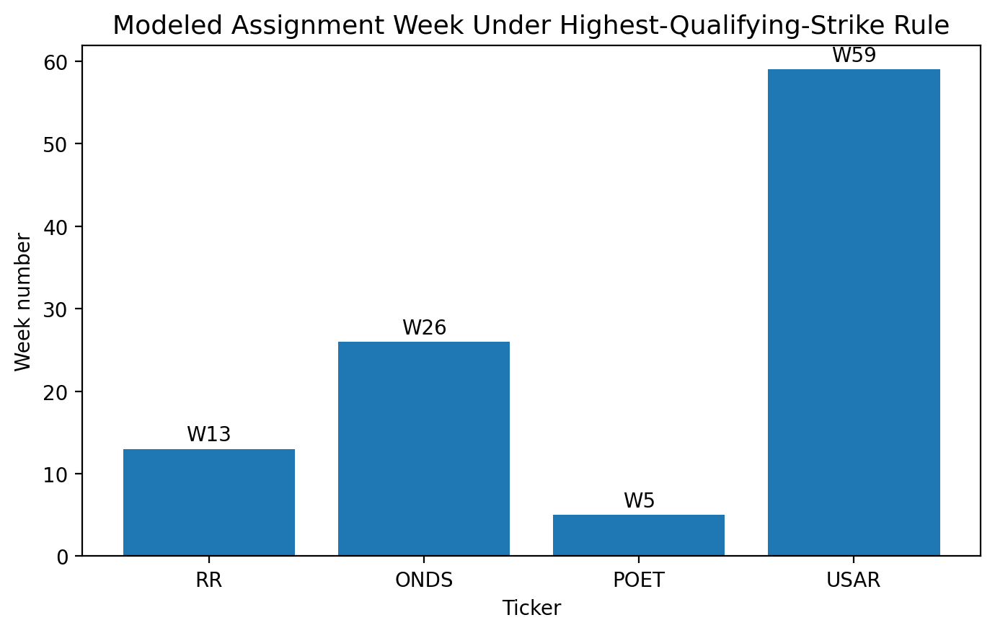
Figure 1. Modeled assignment week under the final highest-qualifying-strike rule.
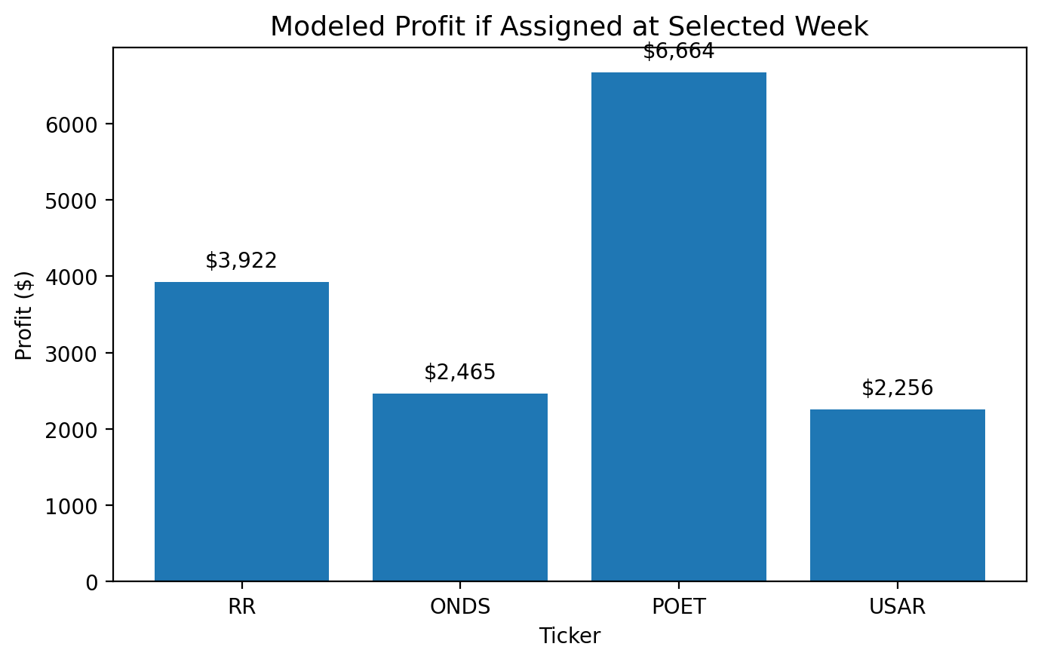
Figure 2. Modeled total profit if assigned at the selected assignment week.
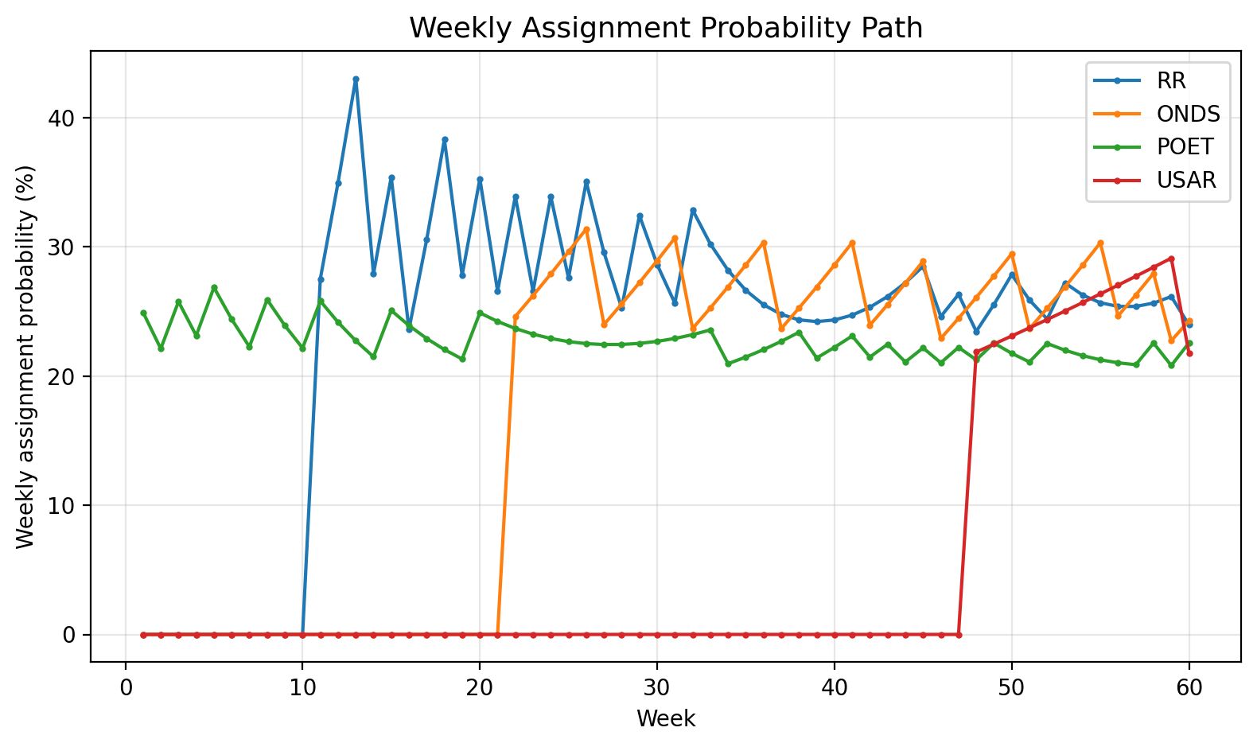
Figure 3. Weekly assignment probability path. The selected assignment week is where each ticker reaches its highest q_t under the final rule.
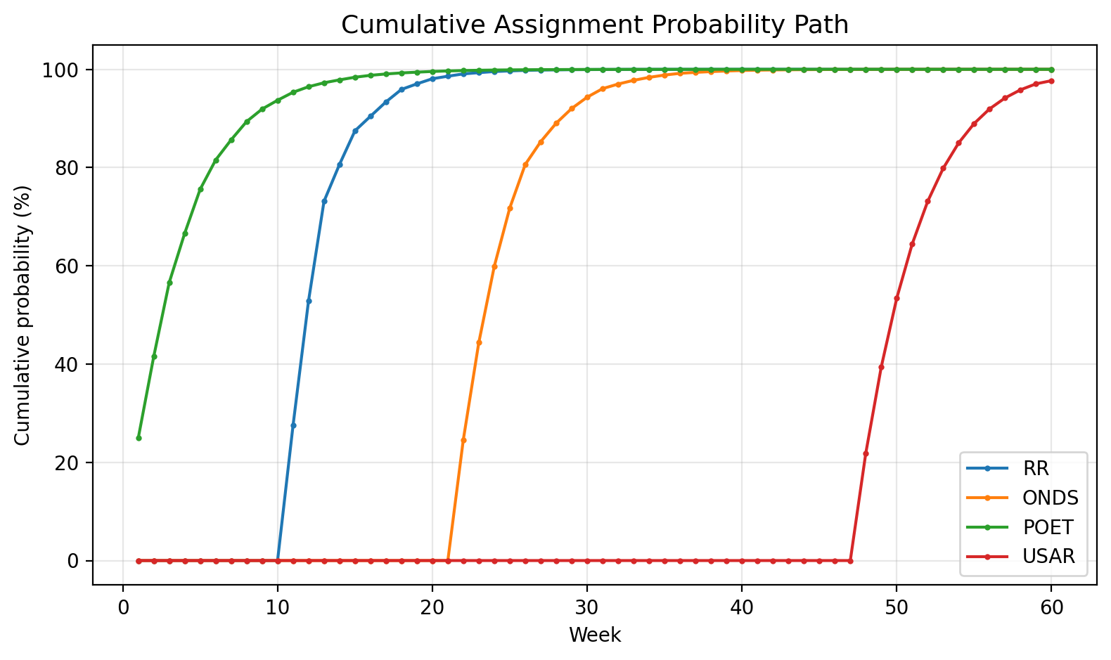
Figure 4. Cumulative assignment probability through week 60. Cumulative probability is a risk metric, not the assignment-week rule.
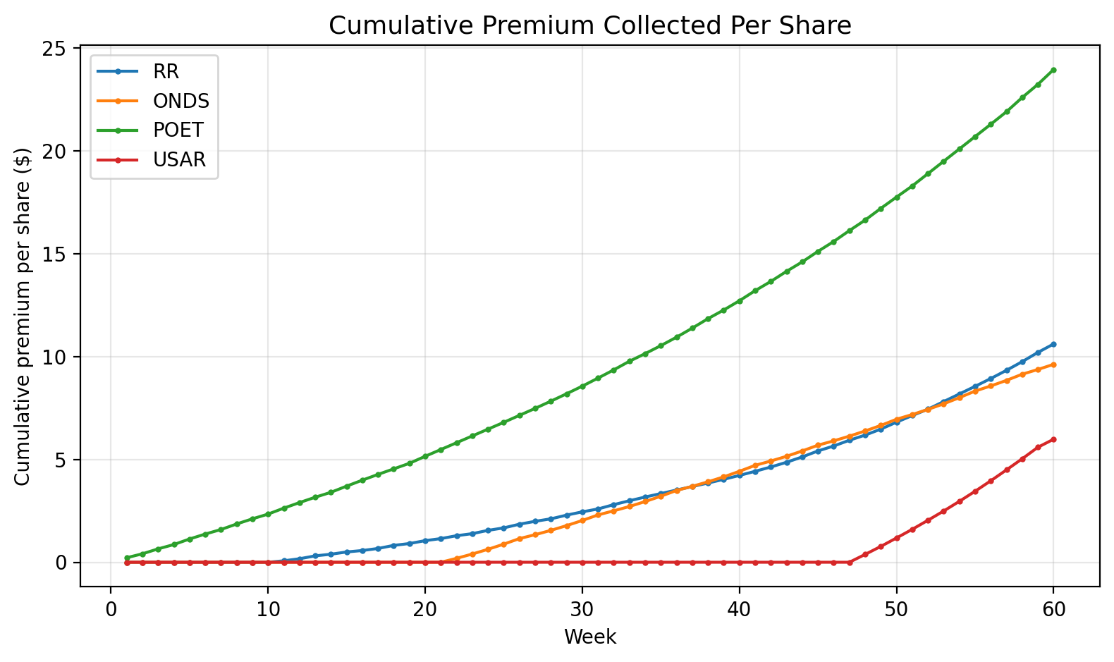
Figure 5. Modeled cumulative premium per share under the final strategy.
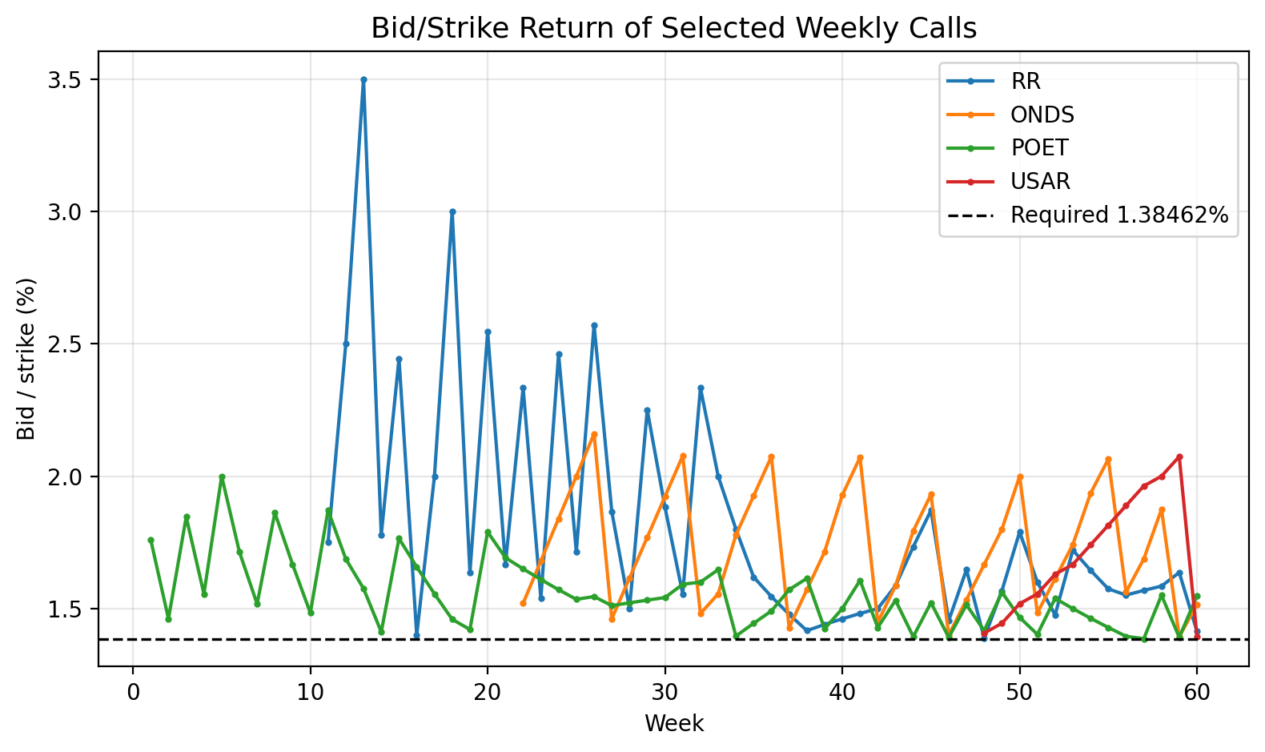
Figure 6. Selected-call bid/strike return versus the 1.38462% minimum requirement.
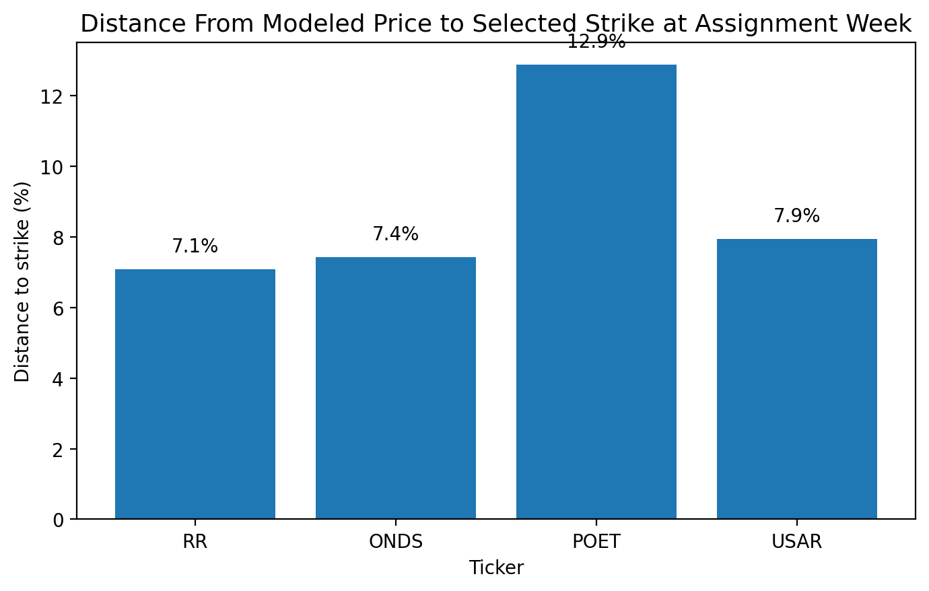
Figure 7. Distance between modeled stock price and selected strike at the assignment week.
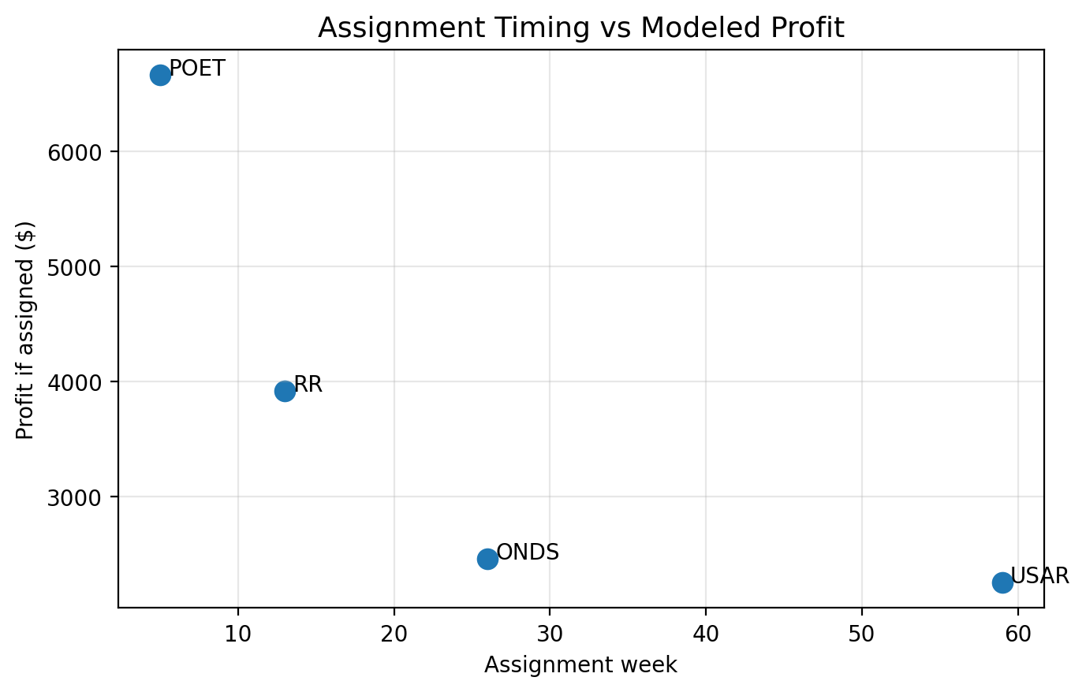
Figure 8. Tradeoff between assignment timing and modeled profit.

7. Ticker-Level Show Work
This section shows the assignment-week calculation for each ticker. The tables report the exact modeled inputs at the selected week: S_t, B_t, K_t, Black-Scholes d1/d2, theoretical mid, modeled bid, bid/strike, weekly assignment probability, cumulative premium, and total profit if assigned.

7.1 POET: POET Technologies Inc.
Position: 2,800 shares, average cost A = $12.25, starting price S0 = $10.77, annualized IV = 133.16%, put/call ratio = 0.32.
sigma_w = 1.3316 * sqrt(5/252) = 0.1876 (POET-1)
g = clip(0.15 * 0.1876 * ln(0.70/0.32), -0.04, 0.04) = 0.0220 (POET-2)
S_5 = 10.77 * exp(0.0220 * (5 - 1)) = 11.76 (POET-3)
B_t = max(11.76, 12.25) = 12.25 (POET-4)
The selected strike is the highest strike on the model grid such that K >= B_t and Bid/K >= 1.38462%. The selected strike is K = $13.50.
d_1 = -0.6363; d_2 = -0.8239 (POET-5)
C_BS = 0.3199; Bid = floor_to_cent(0.85*C_BS) = 0.27 (POET-6)
Bid/K = 0.27/13.50 = 2.00% (POET-7)
q_t = 1 - Phi(([ln(13.50/11.76) - 0.0220] / 0.1876)) = 26.85% (POET-8)
Profit = 2,800 * (13.50 - 12.25 + 1.13) = $6,664 (POET-9)
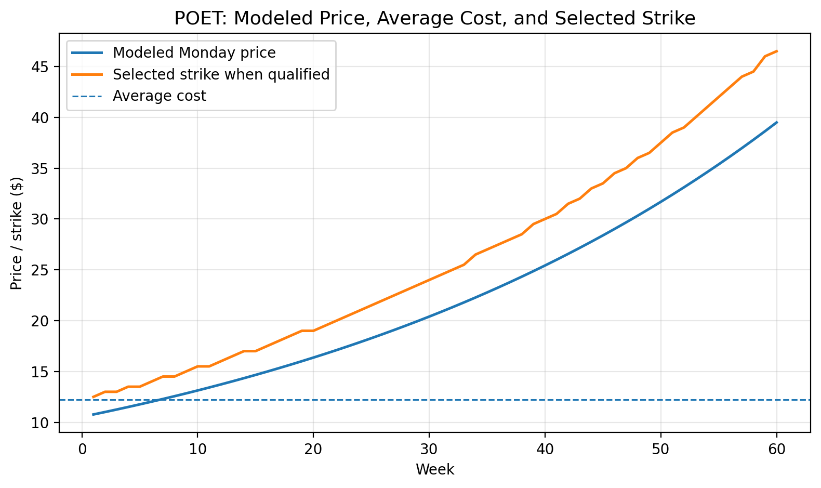
Figure 9. POET: modeled Monday price, average cost, and selected qualifying strikes.
Week | S_t | B_t | Strike | Bid | Bid/K | q_t | P_cum | Cum prem/share
1 | $10.77 | $12.25 | $12.50 | $0.22 | 1.76% | 24.93% | 24.93% | $0.22
2 | $11.01 | $12.25 | $13.00 | $0.19 | 1.46% | 22.11% | 41.53% | $0.41
3 | $11.25 | $12.25 | $13.00 | $0.24 | 1.85% | 25.75% | 56.58% | $0.65
4 | $11.51 | $12.25 | $13.50 | $0.21 | 1.56% | 23.12% | 66.62% | $0.86
5 | $11.76 | $12.25 | $13.50 | $0.27 | 2.00% | 26.85% | 75.58% | $1.13
6 | $12.02 | $12.25 | $14.00 | $0.24 | 1.71% | 24.39% | 81.54% | $1.37
7 | $12.29 | $12.29 | $14.50 | $0.22 | 1.52% | 22.26% | 85.65% | $1.59
8 | $12.57 | $12.57 | $14.50 | $0.27 | 1.86% | 25.91% | 89.37% | $1.86
60 | $39.49 | $39.49 | $46.50 | $0.72 | 1.55% | 22.56% | 100.00% | $23.95
Table 3. POET weekly checkpoint table around the selected assignment week.

7.2 RR: Richtech Robotics Inc.
Position: 7,400 shares, average cost A = $3.78, starting price S0 = $2.30, annualized IV = 134.76%, put/call ratio = 0.07.
sigma_w = 1.3476 * sqrt(5/252) = 0.1898 (RR-1)
g = clip(0.15 * 0.1898 * ln(0.70/0.07), -0.04, 0.04) = 0.0400 (RR-2)
S_13 = 2.30 * exp(0.0400 * (13 - 1)) = 3.72 (RR-3)
B_t = max(3.72, 3.78) = 3.78 (RR-4)
The selected strike is the highest strike on the model grid such that K >= B_t and Bid/K >= 1.38462%. The selected strike is K = $4.00.
d_1 = -0.2870; d_2 = -0.4768 (RR-5)
C_BS = 0.1728; Bid = floor_to_cent(0.85*C_BS) = 0.14 (RR-6)
Bid/K = 0.14/4.00 = 3.50% (RR-7)
q_t = 1 - Phi(([ln(4.00/3.72) - 0.0400] / 0.1898)) = 43.02% (RR-8)
Profit = 7,400 * (4.00 - 3.78 + 0.31) = $3,922 (RR-9)
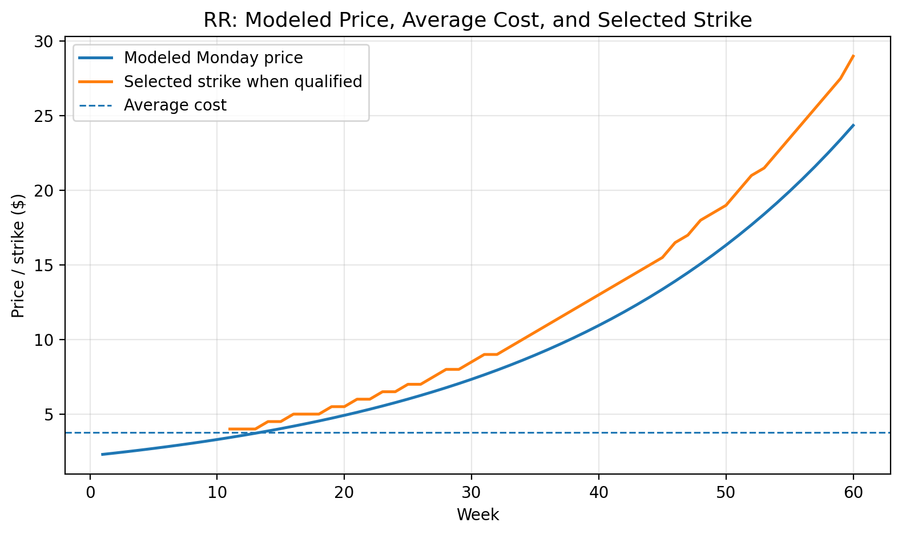
Figure 10. RR: modeled Monday price, average cost, and selected qualifying strikes.
Week | S_t | B_t | Strike | Bid | Bid/K | q_t | P_cum | Cum prem/share
1 | $2.30 | $3.78 | No trade | $0.00 | 0.00% | 0.00% | 0.00% | $0.00
10 | $3.30 | $3.78 | No trade | $0.00 | 0.00% | 0.00% | 0.00% | $0.00
11 | $3.43 | $3.78 | $4.00 | $0.07 | 1.75% | 27.51% | 27.51% | $0.07
12 | $3.57 | $3.78 | $4.00 | $0.10 | 2.50% | 34.95% | 52.85% | $0.17
13 | $3.72 | $3.78 | $4.00 | $0.14 | 3.50% | 43.02% | 73.13% | $0.31
14 | $3.87 | $3.87 | $4.50 | $0.08 | 1.78% | 27.91% | 80.63% | $0.39
15 | $4.03 | $4.03 | $4.50 | $0.11 | 2.44% | 35.39% | 87.48% | $0.50
16 | $4.19 | $4.19 | $5.00 | $0.07 | 1.40% | 23.60% | 90.44% | $0.57
60 | $24.36 | $24.36 | $29.00 | $0.41 | 1.41% | 23.95% | 100.00% | $10.61
Table 4. RR weekly checkpoint table around the selected assignment week.

7.3 ONDS: Ondas Holdings Inc.
Position: 1,700 shares, average cost A = $12.20, starting price S0 = $9.65, annualized IV = 102.21%, put/call ratio = 0.50.
sigma_w = 1.0221 * sqrt(5/252) = 0.1440 (ONDS-1)
g = clip(0.15 * 0.1440 * ln(0.70/0.50), -0.04, 0.04) = 0.0073 (ONDS-2)
S_26 = 9.65 * exp(0.0073 * (26 - 1)) = 11.57 (ONDS-3)
B_t = max(11.57, 12.20) = 12.20 (ONDS-4)
The selected strike is the highest strike on the model grid such that K >= B_t and Bid/K >= 1.38462%. The selected strike is K = $12.50.
d_1 = -0.4574; d_2 = -0.6014 (ONDS-5)
C_BS = 0.3265; Bid = floor_to_cent(0.85*C_BS) = 0.27 (ONDS-6)
Bid/K = 0.27/12.50 = 2.16% (ONDS-7)
q_t = 1 - Phi(([ln(12.50/11.57) - 0.0073] / 0.1440)) = 31.38% (ONDS-8)
Profit = 1,700 * (12.50 - 12.20 + 1.15) = $2,465 (ONDS-9)
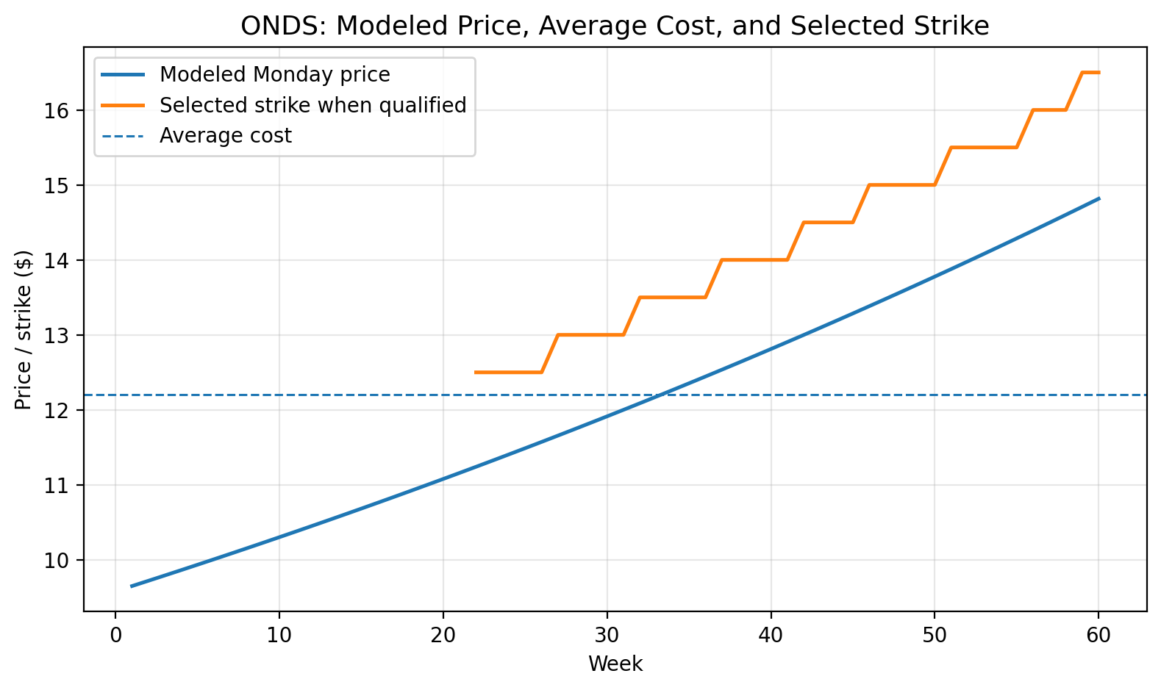
Figure 11. ONDS: modeled Monday price, average cost, and selected qualifying strikes.
Week | S_t | B_t | Strike | Bid | Bid/K | q_t | P_cum | Cum prem/share
1 | $9.65 | $12.20 | No trade | $0.00 | 0.00% | 0.00% | 0.00% | $0.00
23 | $11.32 | $12.20 | $12.50 | $0.21 | 1.68% | 26.22% | 44.37% | $0.40
24 | $11.41 | $12.20 | $12.50 | $0.23 | 1.84% | 27.89% | 59.89% | $0.63
25 | $11.49 | $12.20 | $12.50 | $0.25 | 2.00% | 29.61% | 71.77% | $0.88
26 | $11.57 | $12.20 | $12.50 | $0.27 | 2.16% | 31.38% | 80.63% | $1.15
27 | $11.66 | $12.20 | $13.00 | $0.19 | 1.46% | 23.98% | 85.27% | $1.34
28 | $11.74 | $12.20 | $13.00 | $0.21 | 1.62% | 25.57% | 89.04% | $1.55
29 | $11.83 | $12.20 | $13.00 | $0.23 | 1.77% | 27.22% | 92.02% | $1.78
60 | $14.82 | $14.82 | $16.50 | $0.25 | 1.52% | 24.27% | 100.00% | $9.62
Table 5. ONDS weekly checkpoint table around the selected assignment week.

7.4 USAR: USA Rare Earth Inc.
Position: 400 shares, average cost A = $26.95, starting price S0 = $20.90, annualized IV = 102.83%, put/call ratio = 0.61.
sigma_w = 1.0283 * sqrt(5/252) = 0.1448 (USAR-1)
g = clip(0.15 * 0.1448 * ln(0.70/0.61), -0.04, 0.04) = 0.0030 (USAR-2)
S_59 = 20.90 * exp(0.0030 * (59 - 1)) = 24.86 (USAR-3)
B_t = max(24.86, 26.95) = 26.95 (USAR-4)
The selected strike is the highest strike on the model grid such that K >= B_t and Bid/K >= 1.38462%. The selected strike is K = $27.00.
d_1 = -0.4921; d_2 = -0.6370 (USAR-5)
C_BS = 0.6690; Bid = floor_to_cent(0.85*C_BS) = 0.56 (USAR-6)
Bid/K = 0.56/27.00 = 2.07% (USAR-7)
q_t = 1 - Phi(([ln(27.00/24.86) - 0.0030] / 0.1448)) = 29.11% (USAR-8)
Profit = 400 * (27.00 - 26.95 + 5.59) = $2,256 (USAR-9)
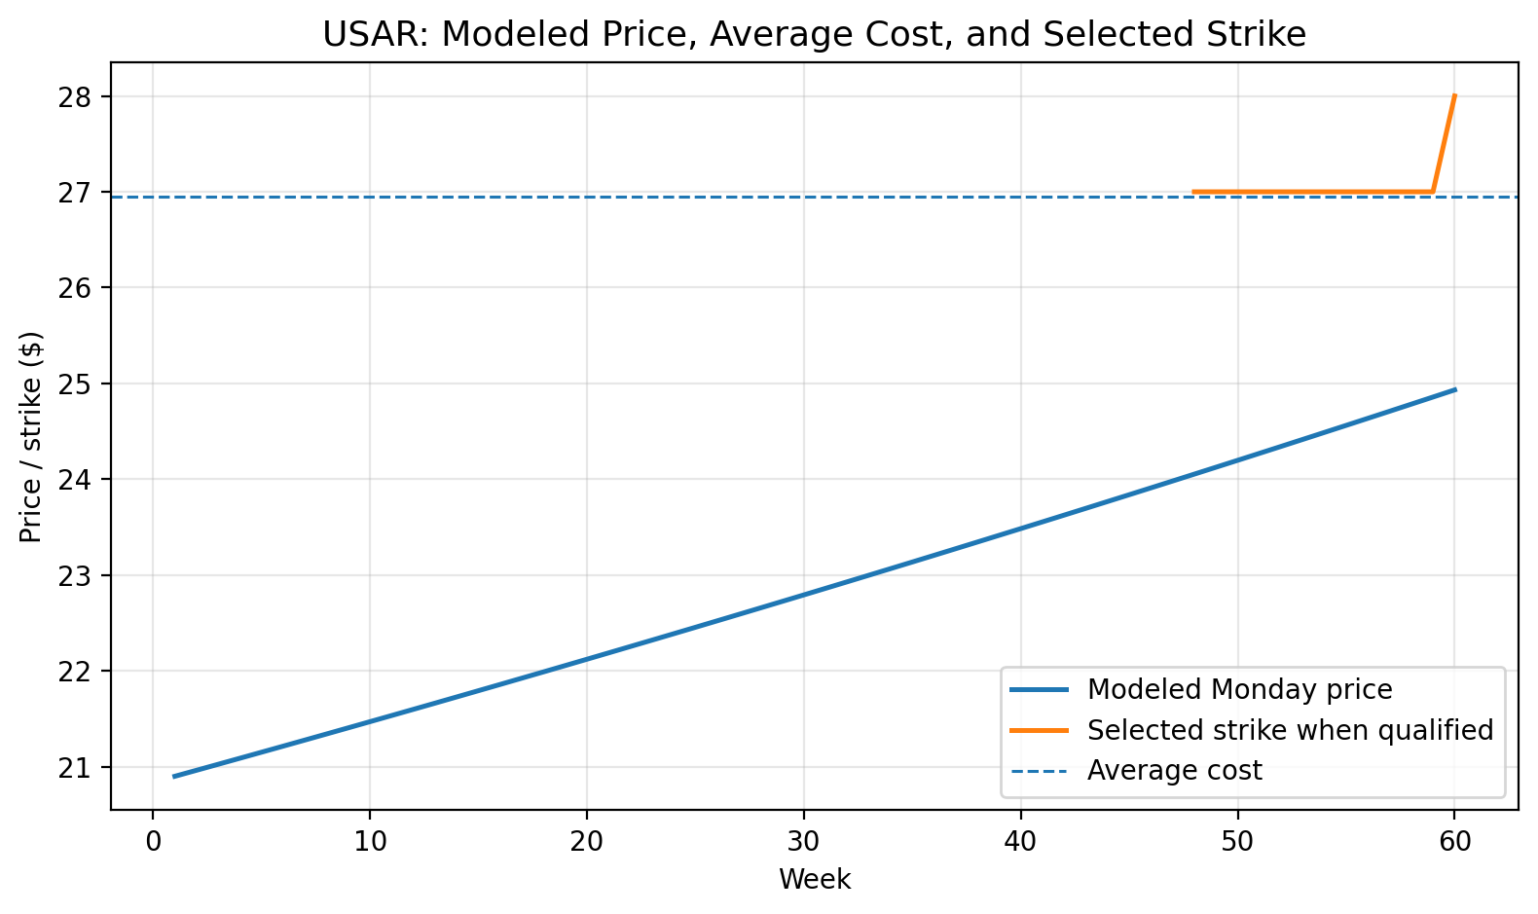
Figure 12. USAR: modeled Monday price, average cost, and selected qualifying strikes.
Week | S_t | B_t | Strike | Bid | Bid/K | q_t | P_cum | Cum prem/share
1 | $20.90 | $26.95 | No trade | $0.00 | 0.00% | 0.00% | 0.00% | $0.00
56 | $24.64 | $26.95 | $27.00 | $0.51 | 1.89% | 27.03% | 91.95% | $3.96
57 | $24.71 | $26.95 | $27.00 | $0.53 | 1.96% | 27.71% | 94.18% | $4.49
58 | $24.78 | $26.95 | $27.00 | $0.54 | 2.00% | 28.41% | 95.83% | $5.03
59 | $24.86 | $26.95 | $27.00 | $0.56 | 2.07% | 29.11% | 97.05% | $5.59
60 | $24.93 | $26.95 | $28.00 | $0.39 | 1.39% | 21.75% | 97.69% | $5.98
61 | $25.01 | $26.95 | $28.00 | $0.40 | 1.43% | 22.37% | 98.21% | $6.38
62 | $25.08 | $26.95 | $28.00 | $0.42 | 1.50% | 22.99% | 98.62% | $6.80
Table 6. USAR weekly checkpoint table around the selected assignment week.

8. Interpretation and Portfolio Ranking
The model ranks POET as the best fit because it begins qualifying immediately, produces the earliest highest-probability assignment week, and has the best combination of premium and above-cost assignment profit. RR ranks second because its call-heavy put/call ratio produces the strongest modeled drift, but it needs a recovery toward the average cost area before safe strikes qualify. ONDS and USAR are structurally safer than selling below-cost strikes, but they are slower because the stock price begins farther below the required strike floor.
Rank | Ticker | Assignment week | Modeled profit | Reason
1 | POET | 5 | $6,664 | Fastest qualifying setup; high IV; modeled assignment in week 5 with strong assignment profit.
2 | RR | 13 | $3,922 | High call-heavy sentiment and strong drift assumption; meaningful only after recovery toward $4.
3 | ONDS | 26 | $2,465 | Safe above-cost assignment, but qualifying premium does not begin until later in the model.
4 | USAR | 59 | $2,256 | Very slow under this rule; profit mainly comes from repeated premium rather than strike spread.
Table 7. Strategy fit ranking based on timing, premium availability, assignment probability, and profit.

9. Risk, Limitations, and Practical Controls
Black-Scholes limitations: The Black-Scholes framework assumes lognormal returns, constant volatility, frictionless markets, and European-style exercise. Listed equity options are generally American-style, so early exercise and real assignment behavior can differ from this model [1][3].
Liquidity and bid risk: The modeled bid is 85% of Black-Scholes value and floored to cents. Actual bid/ask spreads may be wider, especially in high-volatility small-cap names. A theoretical qualifying strike may not be fillable.
Put/call ratio interpretation: The model treats low put/call volume as bullish momentum. Some traders interpret extreme low put/call ratios contrarily. The report uses this as a controlled drift input, not as a fact about future returns [4].
Path dependence: If the stock declines, future above-cost strikes may stop qualifying. If the stock rises fast, assignment could occur earlier than the selected highest-probability week.
Assignment uncertainty: OCC notes that no magic number guarantees an option writer will not be assigned. Assignment can occur based on holder exercise behavior and broker procedures [3].
Portfolio concentration: The positions are concentrated in volatile stocks. Covered calls do not remove downside equity risk; they only offset some losses via premium [2].
Compliance/taxes: If the investor works at a finance company or has restricted trading, preclearance, automatic trading limits, personal account dealing policies, and tax consequences must be checked before implementation.

9.1 Monday Execution Checklist
Refresh live stock price, IV, and put/call volume for each ticker.
Confirm exact share count and existing short-call exposure.
Calculate B_t = max(S_t, A).
Pull the same-week Friday option chain.
Remove strikes below B_t.
Calculate actual bid/strike using live bid, not model bid.
Select the highest strike with bid/strike >= 1.38462%.
If no strike qualifies, skip rather than lowering the strike below average cost.
Use limit orders and avoid market orders in illiquid contracts.
Record premium, strike, expiration, and updated cumulative premium.

10. Conclusion
Under the final strict rule, the strategy is most attractive when a ticker has high implied volatility, supportive put/call sentiment, and a current stock price close enough to average cost that above-cost strikes can still produce at least 1.38462% bid/strike return. POET currently fits this profile best. RR can work in the model, but the outcome depends heavily on continued bullish drift from its call-heavy option flow. ONDS and USAR are slower because above-cost strikes do not produce enough return until the modeled price path approaches the average-cost region.
The strategy should not be treated as a guarantee of recovery. It is a weekly decision rule. Each Monday, the model must be re-run with current price, actual option-chain bids, updated implied volatility, current put/call volume, and the exact remaining share count. The safest form of the rule remains: do not sell below original average cost if assignment must always be above cost.

References
[1] Black, F., & Scholes, M. (1973). The Pricing of Options and Corporate Liabilities. Journal of Political Economy, 81(3), 637-654. https://www.cs.princeton.edu/courses/archive/fall09/cos323/papers/black_scholes73.pdf
[2] The Options Clearing Corporation. Get the Facts About Covered Calls. https://www.theocc.com/newsroom/insights/2018/08-15-get-the-facts-about-covered-calls
[3] Options Industry Council / OCC. Options Assignment FAQ. https://www.optionseducation.org/referencelibrary/faq/options-assignment
[4] Barchart. Options Put/Call Ratios and market-sentiment description. https://www.barchart.com/options
[5] Barchart. Implied Volatility, IV Rank, and IV Percentile definitions. https://www.barchart.com/options/iv-rank-percentile
[6] Barchart. Stock option quote and put/call ratio pages for RR, ONDS, POET, and USAR. https://www.barchart.com/stocks/quotes/
[7] Market snapshot used for starting prices: RR, ONDS, POET, and USAR quotes retrieved through Robinhood finance market data tool on June 10, 2026 UTC. Values should be replaced by live quotes before trading.

Appendix A. Model Inputs
Ticker | Annual IV | PCR | Weekly vol | Weekly drift g | Start price | Avg cost | Shares
RR | 134.76% | 0.07 | 18.98% | 4.00% | $2.30 | $3.78 | 7,400
ONDS | 102.21% | 0.5 | 14.40% | 0.73% | $9.65 | $12.20 | 1,700
POET | 133.16% | 0.32 | 18.76% | 2.20% | $10.77 | $12.25 | 2,800
USAR | 102.83% | 0.61 | 14.48% | 0.30% | $20.90 | $26.95 | 400
Appendix Table A1. Core model inputs and derived weekly volatility/drift values.

Appendix B. Weekly Checkpoint Tables
The tables below provide selected checkpoints from the model. Full week-by-week CSV files were generated internally from the same calculations used to produce the document figures.

Appendix B.1 RR checkpoint trace
Week | S_t | B_t | K_t | Bid | Bid/K | q_t | P_cum | Cum prem/share
1 | $2.30 | $3.78 | No trade | $0.00 | 0.00% | 0.00% | 0.00% | $0.00
5 | $2.70 | $3.78 | No trade | $0.00 | 0.00% | 0.00% | 0.00% | $0.00
10 | $3.30 | $3.78 | No trade | $0.00 | 0.00% | 0.00% | 0.00% | $0.00
12 | $3.57 | $3.78 | $4.00 | $0.10 | 2.50% | 34.95% | 52.85% | $0.17
13 | $3.72 | $3.78 | $4.00 | $0.14 | 3.50% | 43.02% | 73.13% | $0.31
14 | $3.87 | $3.87 | $4.50 | $0.08 | 1.78% | 27.91% | 80.63% | $0.39
15 | $4.03 | $4.03 | $4.50 | $0.11 | 2.44% | 35.39% | 87.48% | $0.50
20 | $4.92 | $4.92 | $5.50 | $0.14 | 2.55% | 35.25% | 98.08% | $1.05
25 | $6.01 | $6.01 | $7.00 | $0.12 | 1.71% | 27.58% | 99.67% | $1.67
30 | $7.34 | $7.34 | $8.50 | $0.16 | 1.88% | 28.62% | 99.95% | $2.45
35 | $8.96 | $8.96 | $10.50 | $0.17 | 1.62% | 26.63% | 99.99% | $3.34
40 | $10.95 | $10.95 | $13.00 | $0.19 | 1.46% | 24.33% | 100.00% | $4.22
45 | $13.37 | $13.37 | $15.50 | $0.29 | 1.87% | 28.48% | 100.00% | $5.41
50 | $16.33 | $16.33 | $19.00 | $0.34 | 1.79% | 27.84% | 100.00% | $6.81
55 | $19.94 | $19.94 | $23.50 | $0.37 | 1.57% | 25.66% | 100.00% | $8.55
60 | $24.36 | $24.36 | $29.00 | $0.41 | 1.41% | 23.95% | 100.00% | $10.61

Appendix B.2 ONDS checkpoint trace
Week | S_t | B_t | K_t | Bid | Bid/K | q_t | P_cum | Cum prem/share
1 | $9.65 | $12.20 | No trade | $0.00 | 0.00% | 0.00% | 0.00% | $0.00
5 | $9.93 | $12.20 | No trade | $0.00 | 0.00% | 0.00% | 0.00% | $0.00
10 | $10.30 | $12.20 | No trade | $0.00 | 0.00% | 0.00% | 0.00% | $0.00
15 | $10.68 | $12.20 | No trade | $0.00 | 0.00% | 0.00% | 0.00% | $0.00
20 | $11.08 | $12.20 | No trade | $0.00 | 0.00% | 0.00% | 0.00% | $0.00
25 | $11.49 | $12.20 | $12.50 | $0.25 | 2.00% | 29.61% | 71.77% | $0.88
26 | $11.57 | $12.20 | $12.50 | $0.27 | 2.16% | 31.38% | 80.63% | $1.15
27 | $11.66 | $12.20 | $13.00 | $0.19 | 1.46% | 23.98% | 85.27% | $1.34
30 | $11.91 | $12.20 | $13.00 | $0.25 | 1.92% | 28.92% | 94.33% | $2.03
35 | $12.35 | $12.35 | $13.50 | $0.26 | 1.93% | 28.59% | 98.83% | $3.21
40 | $12.81 | $12.81 | $14.00 | $0.27 | 1.93% | 28.58% | 99.76% | $4.42
45 | $13.29 | $13.29 | $14.50 | $0.28 | 1.93% | 28.87% | 99.95% | $5.69
50 | $13.78 | $13.78 | $15.00 | $0.30 | 2.00% | 29.45% | 99.99% | $6.95
55 | $14.29 | $14.29 | $15.50 | $0.32 | 2.06% | 30.31% | 100.00% | $8.32
60 | $14.82 | $14.82 | $16.50 | $0.25 | 1.52% | 24.27% | 100.00% | $9.62

Appendix B.3 POET checkpoint trace
Week | S_t | B_t | K_t | Bid | Bid/K | q_t | P_cum | Cum prem/share
1 | $10.77 | $12.25 | $12.50 | $0.22 | 1.76% | 24.93% | 24.93% | $0.22
4 | $11.51 | $12.25 | $13.50 | $0.21 | 1.56% | 23.12% | 66.62% | $0.86
5 | $11.76 | $12.25 | $13.50 | $0.27 | 2.00% | 26.85% | 75.58% | $1.13
6 | $12.02 | $12.25 | $14.00 | $0.24 | 1.71% | 24.39% | 81.54% | $1.37
10 | $13.13 | $13.13 | $15.50 | $0.23 | 1.48% | 22.16% | 93.70% | $2.34
15 | $14.66 | $14.66 | $17.00 | $0.30 | 1.76% | 25.07% | 98.39% | $3.70
20 | $16.37 | $16.37 | $19.00 | $0.34 | 1.79% | 24.88% | 99.56% | $5.15
25 | $18.27 | $18.27 | $21.50 | $0.33 | 1.53% | 22.66% | 99.88% | $6.80
30 | $20.40 | $20.40 | $24.00 | $0.37 | 1.54% | 22.68% | 99.97% | $8.56
35 | $22.77 | $22.77 | $27.00 | $0.39 | 1.44% | 21.46% | 99.99% | $10.53
40 | $25.42 | $25.42 | $30.00 | $0.45 | 1.50% | 22.21% | 100.00% | $12.71
45 | $28.38 | $28.38 | $33.50 | $0.51 | 1.52% | 22.17% | 100.00% | $15.11
50 | $31.69 | $31.69 | $37.50 | $0.55 | 1.47% | 21.75% | 100.00% | $17.75
55 | $35.38 | $35.38 | $42.00 | $0.60 | 1.43% | 21.25% | 100.00% | $20.69
60 | $39.49 | $39.49 | $46.50 | $0.72 | 1.55% | 22.56% | 100.00% | $23.95

Appendix B.4 USAR checkpoint trace
Week | S_t | B_t | K_t | Bid | Bid/K | q_t | P_cum | Cum prem/share
1 | $20.90 | $26.95 | No trade | $0.00 | 0.00% | 0.00% | 0.00% | $0.00
5 | $21.15 | $26.95 | No trade | $0.00 | 0.00% | 0.00% | 0.00% | $0.00
10 | $21.47 | $26.95 | No trade | $0.00 | 0.00% | 0.00% | 0.00% | $0.00
15 | $21.79 | $26.95 | No trade | $0.00 | 0.00% | 0.00% | 0.00% | $0.00
20 | $22.12 | $26.95 | No trade | $0.00 | 0.00% | 0.00% | 0.00% | $0.00
25 | $22.45 | $26.95 | No trade | $0.00 | 0.00% | 0.00% | 0.00% | $0.00
30 | $22.79 | $26.95 | No trade | $0.00 | 0.00% | 0.00% | 0.00% | $0.00
35 | $23.14 | $26.95 | No trade | $0.00 | 0.00% | 0.00% | 0.00% | $0.00
40 | $23.49 | $26.95 | No trade | $0.00 | 0.00% | 0.00% | 0.00% | $0.00
45 | $23.84 | $26.95 | No trade | $0.00 | 0.00% | 0.00% | 0.00% | $0.00
50 | $24.20 | $26.95 | $27.00 | $0.41 | 1.52% | 23.09% | 53.40% | $1.18
55 | $24.56 | $26.95 | $27.00 | $0.49 | 1.81% | 26.35% | 88.97% | $3.45
58 | $24.78 | $26.95 | $27.00 | $0.54 | 2.00% | 28.41% | 95.83% | $5.03
59 | $24.86 | $26.95 | $27.00 | $0.56 | 2.07% | 29.11% | 97.05% | $5.59
60 | $24.93 | $26.95 | $28.00 | $0.39 | 1.39% | 21.75% | 97.69% | $5.98

Appendix C. Formula Sheet
Weekly base: B_t = max(S_t, A)
Premium requirement: Bid_t(K)/K >= 0.0138462
Strike selection: K_t = max{K : K >= B_t and Bid_t(K)/K >= 0.0138462}
Stock path: S_t = S_0 exp(g(t-1))
Weekly volatility: sigma_w = sigma sqrt(5/252)
Sentiment drift: g = clip(0.15 sigma_w ln(0.70/PCR), -0.04, 0.04)
Black-Scholes call: C = S N(d1) - K exp(-rT)N(d2)
d1: d1 = [ln(S/K)+(r+sigma^2/2)T]/[sigma sqrt(T)]
d2: d2 = d1 - sigma sqrt(T)
Modeled bid: Bid = floor_to_cent(0.85 C)
Weekly assignment probability: q_t = 1 - Phi(([ln(K_t/S_t)-g]/sigma_w))
Cumulative assignment probability: P_cum,n = 1 - product_i(1-q_i)
Profit if assigned: Profit_n = N[K_n - A + sum_i p_i]

